**Employee Management Application architecture and components**

**Document Objective:**

This document describes different layers and components of the application.

1. UPS.Assignment.EmployeeManagement.UI

This is Ui interface through which user can view, search employee details available in Go Rest database using API also user can add new employee or edit, delete employee data.

1. UPS.Assignment.EmployeeManagement.Core

This layer contains supporting methods and property classes according to JSON response format and API query format.

1. UPS.Assignment.EmployeeManagement.Common

This layer contains common utility classes and new custom type converter, and settings classes.

1. UPS.Assignment.EmployeeManagement.ApplicationServices

This layer contains business logic to consume API.

**Additional packages used:**

1. **Newtonsoft.Json**
2. **System.Configuration.ConfigurationManager**
3. **System.Net.Http**
4. **System.XML**

**Different screens of the Application:**

Employee details or main page: Showing initial employee data available in GoRest API with pagination and Search option.

Add Employee, Edit Employee, Delete Employee menus available by which user can perform add edit delete functionality using API.

Export CSV option will generate Tab delimited CSV file of current visible grid data which is also applicable for searched data.

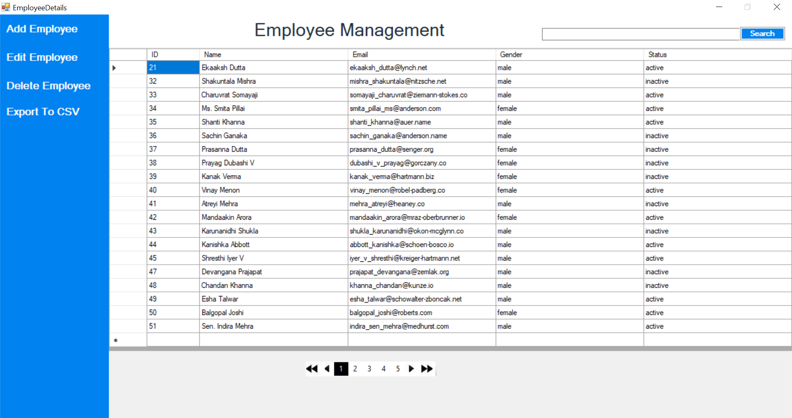

Add/Edit Page:

Using this page user can add or edit new employee data using GoRest API.

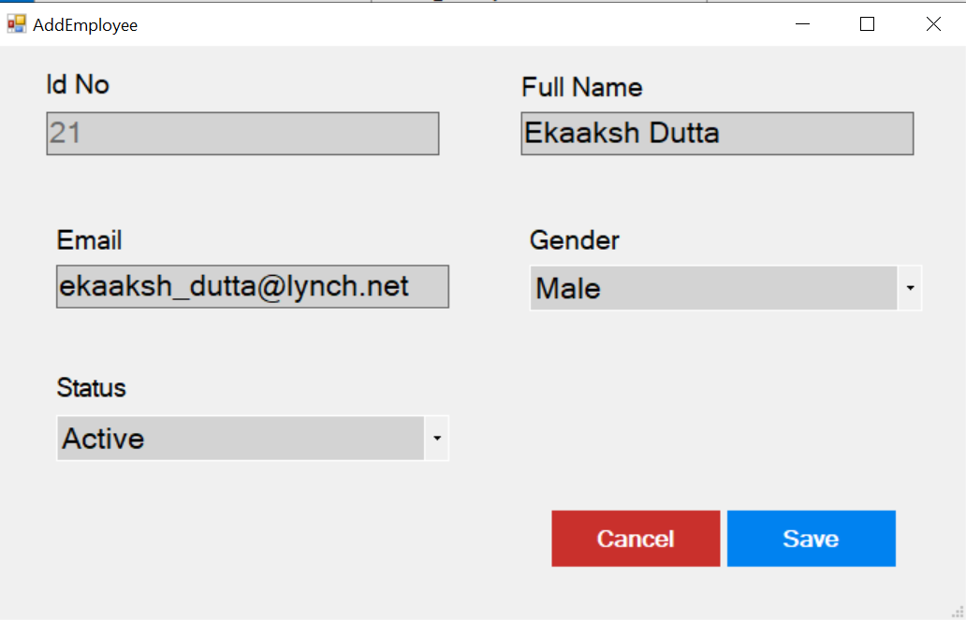

Export to CSV: This functionality will allow user to export visible set of data into a CSV file and save it to a location.

